* Very simple “howfar na” script using Bash

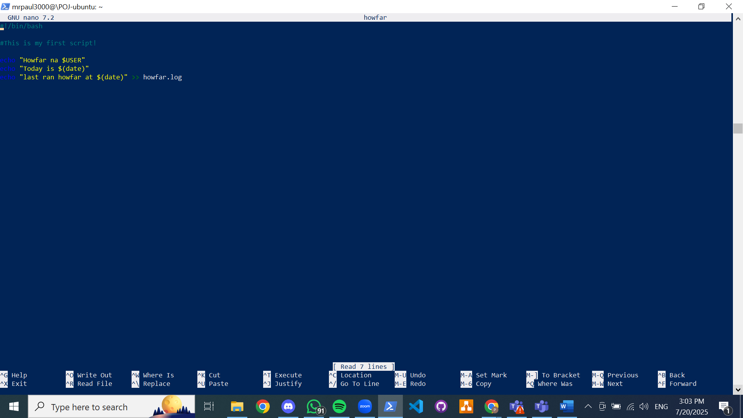

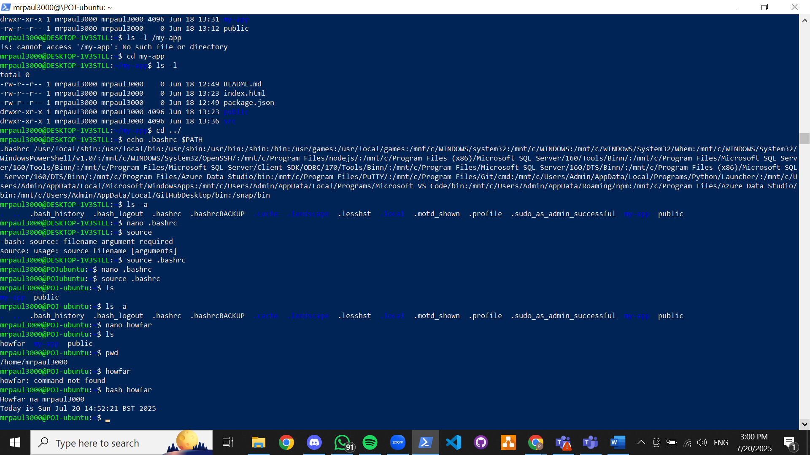

Creating bin folder for script and updating .profile with source command (could be also done by updating $PATH variable in .Bashrc)

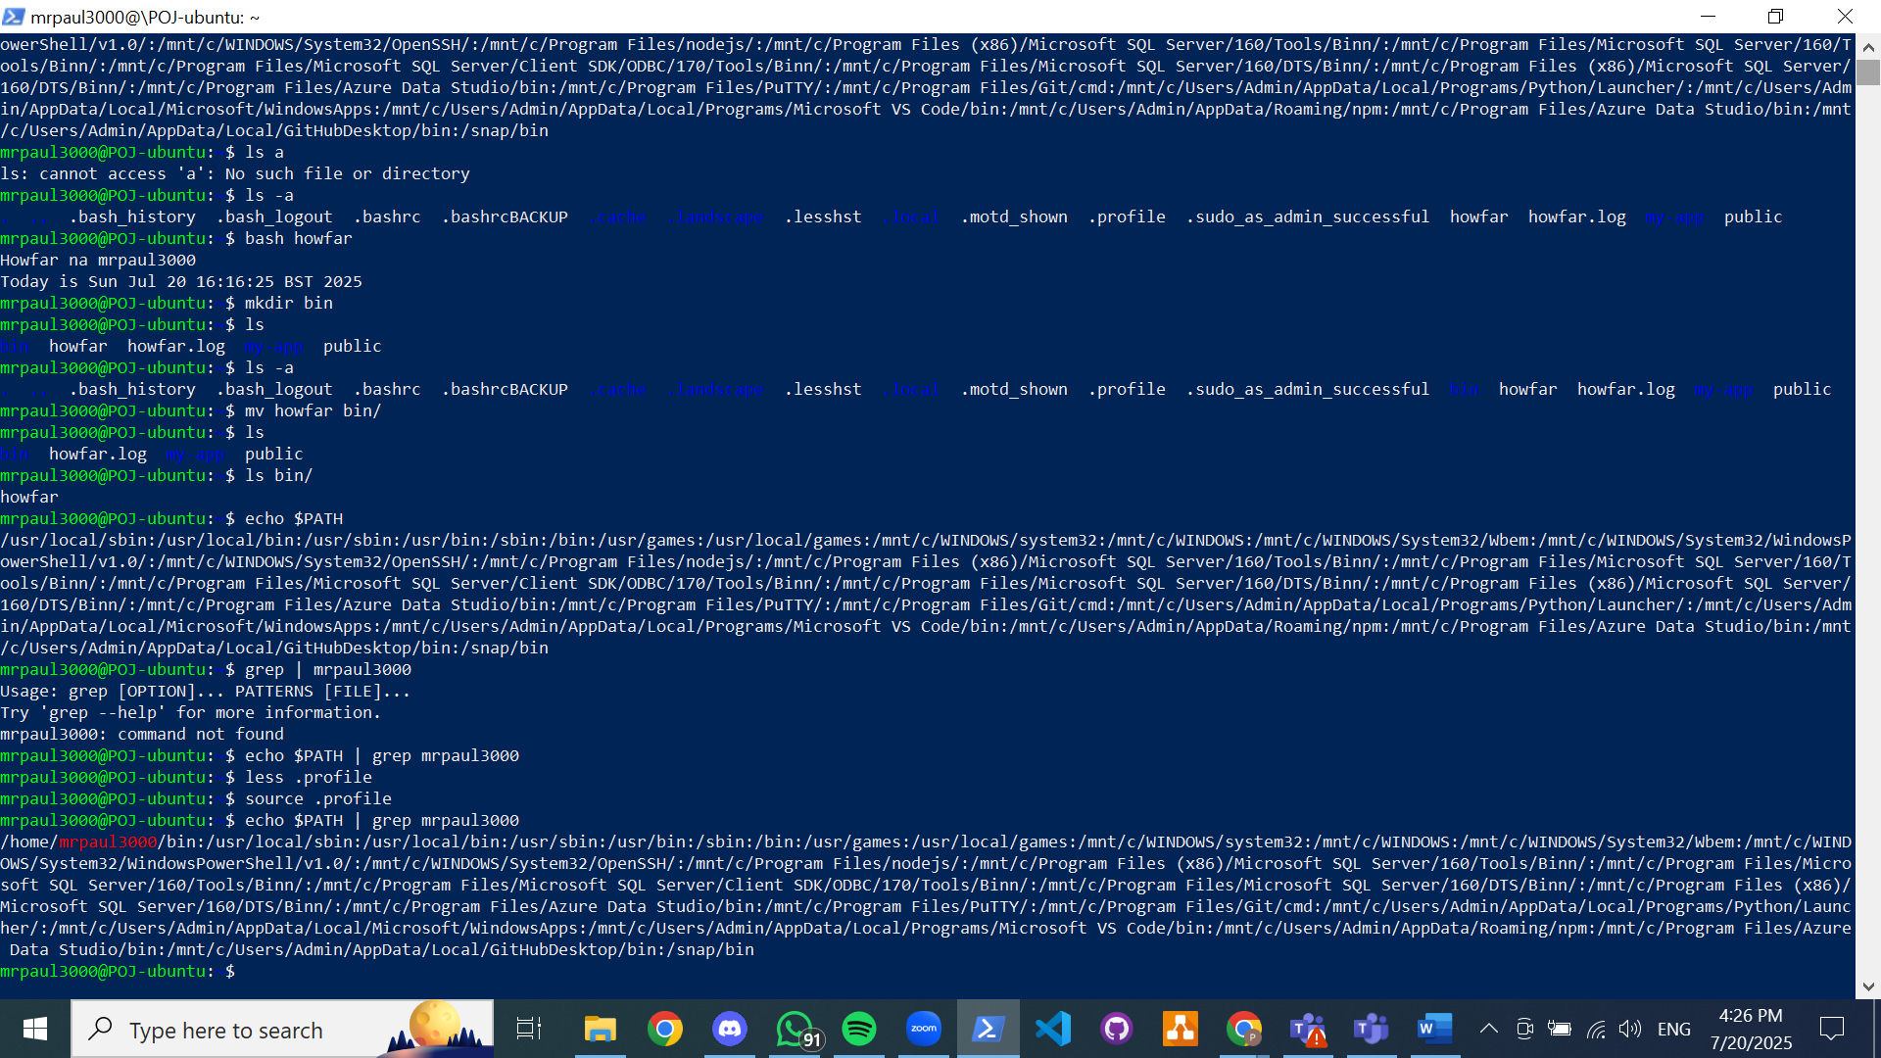

Making the script executable

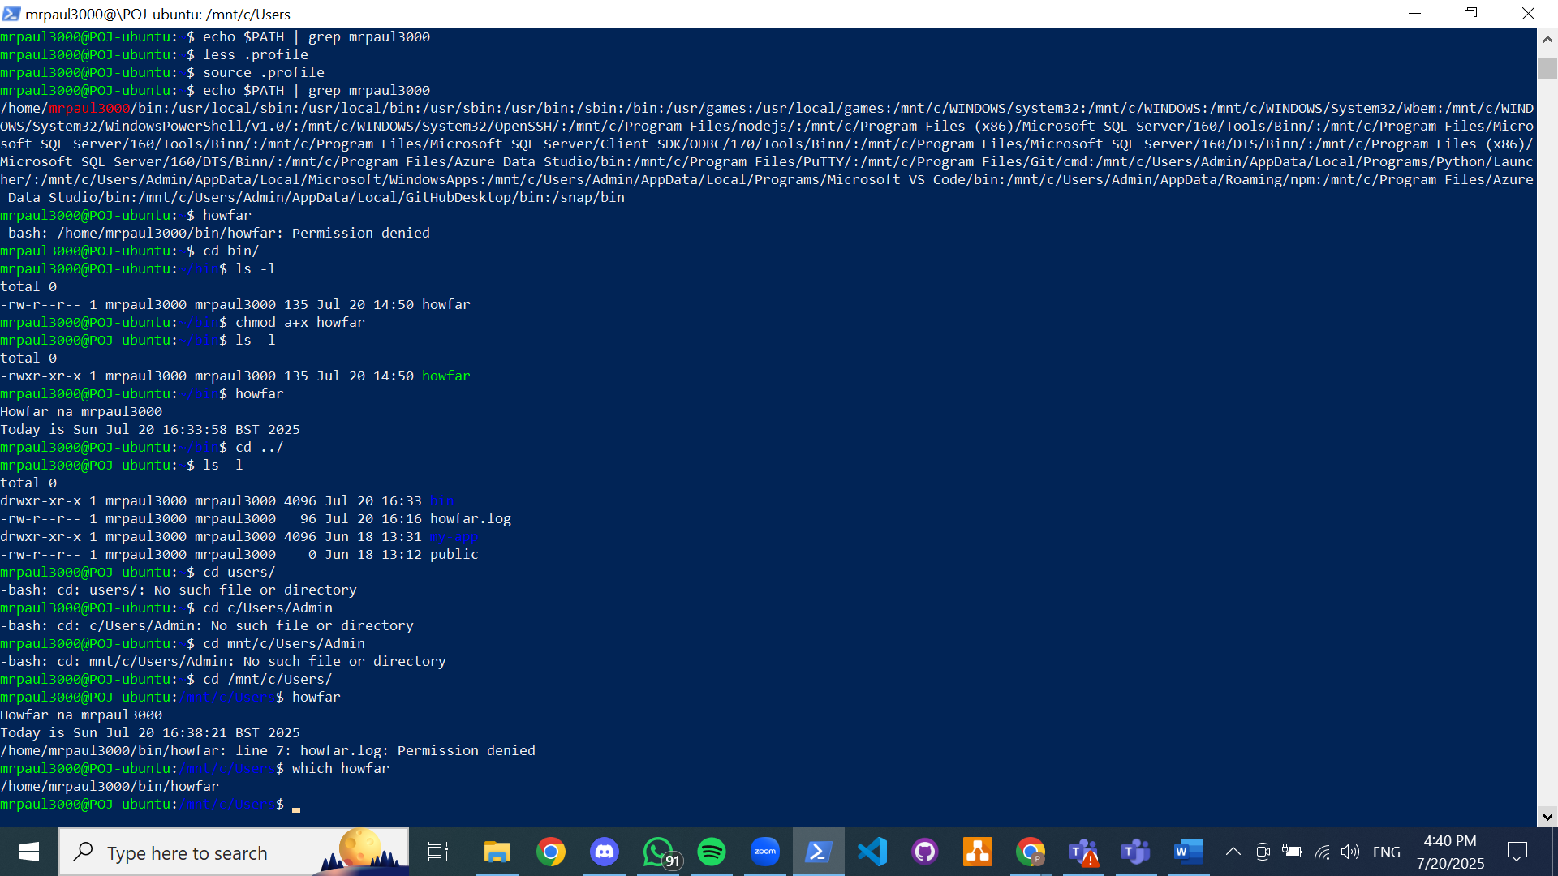

Scripting with python

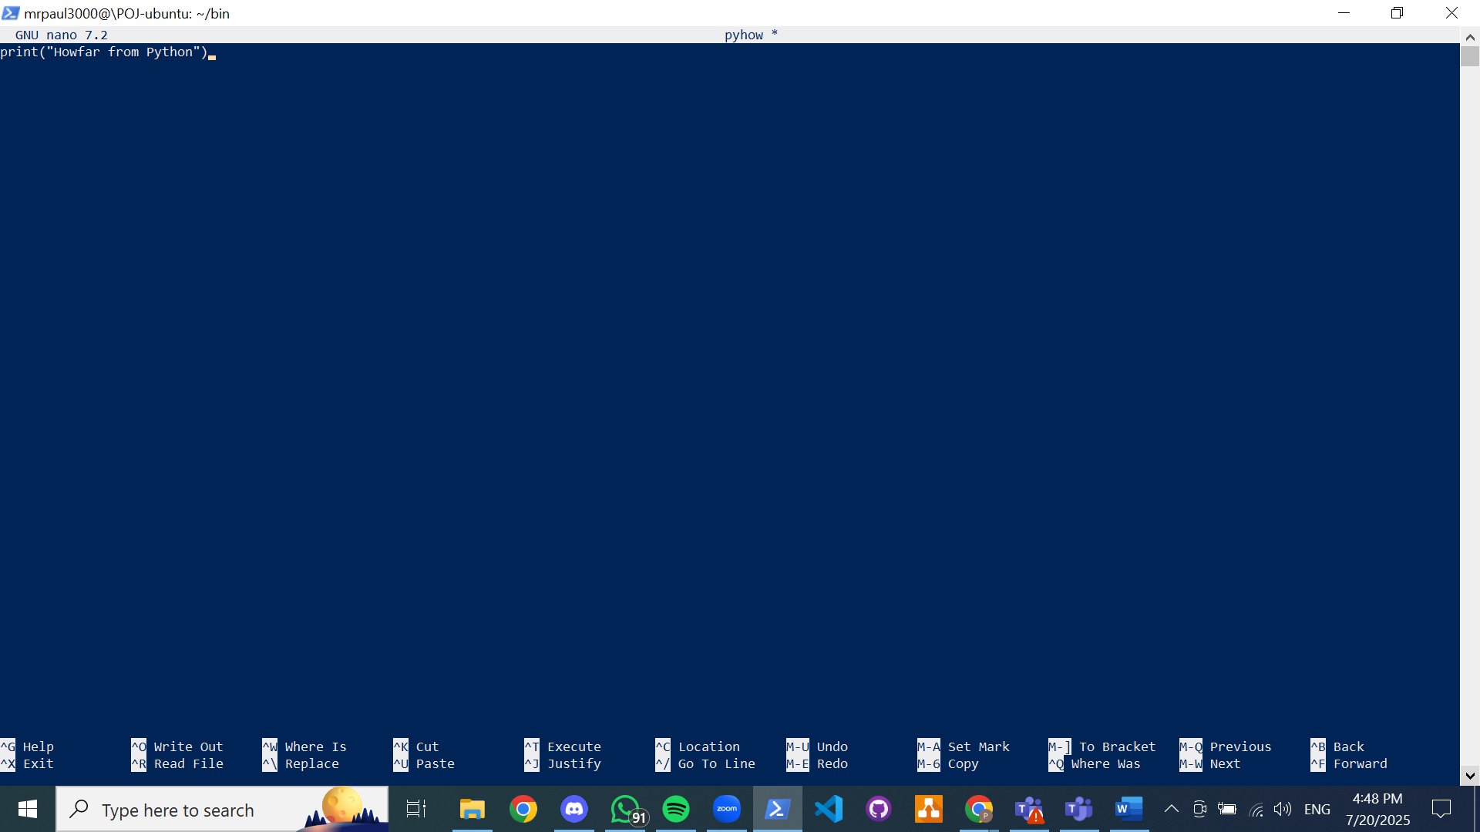

Scripting with perl

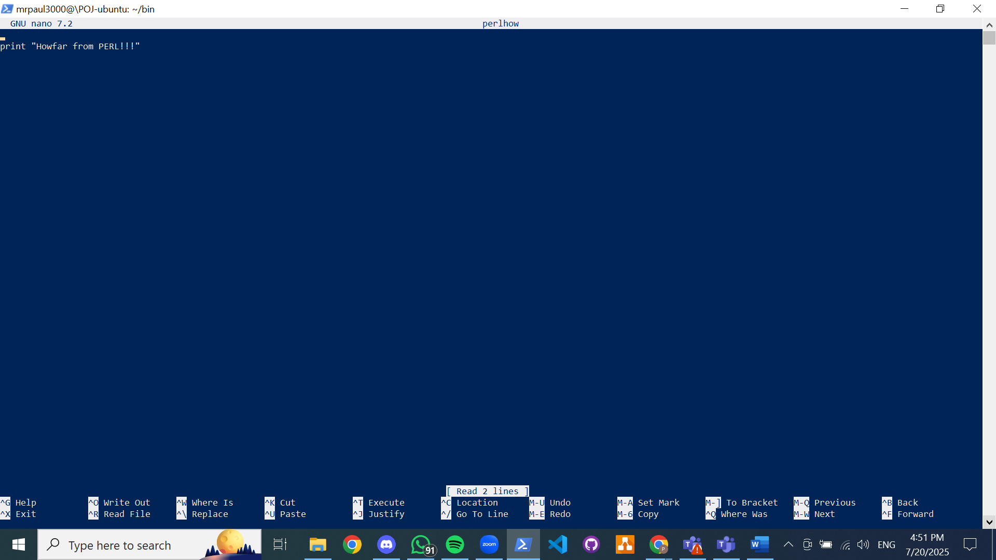

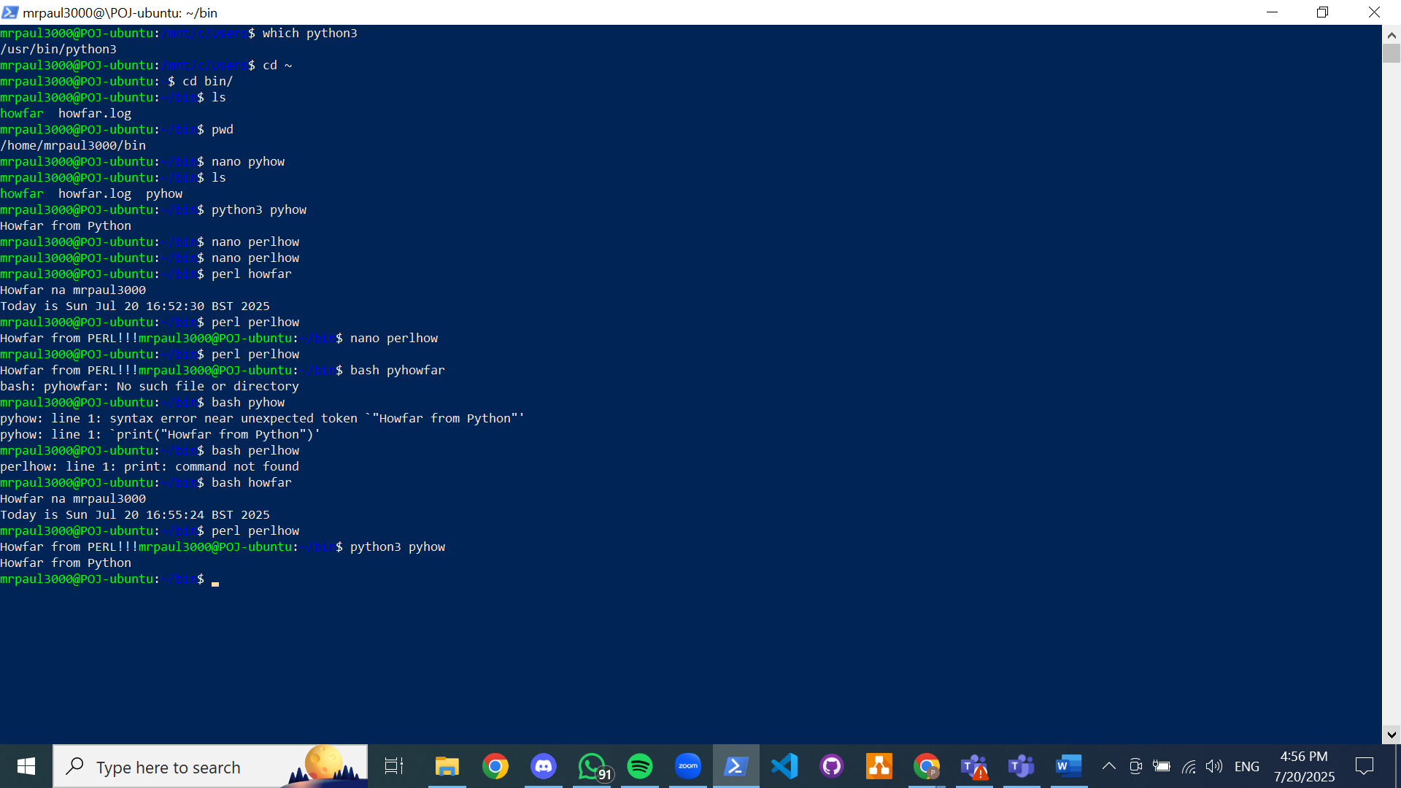

To run with any script language; update script with shebang! #!/usr/bin….PATH..(script language)

Updating perl script (same with python script)

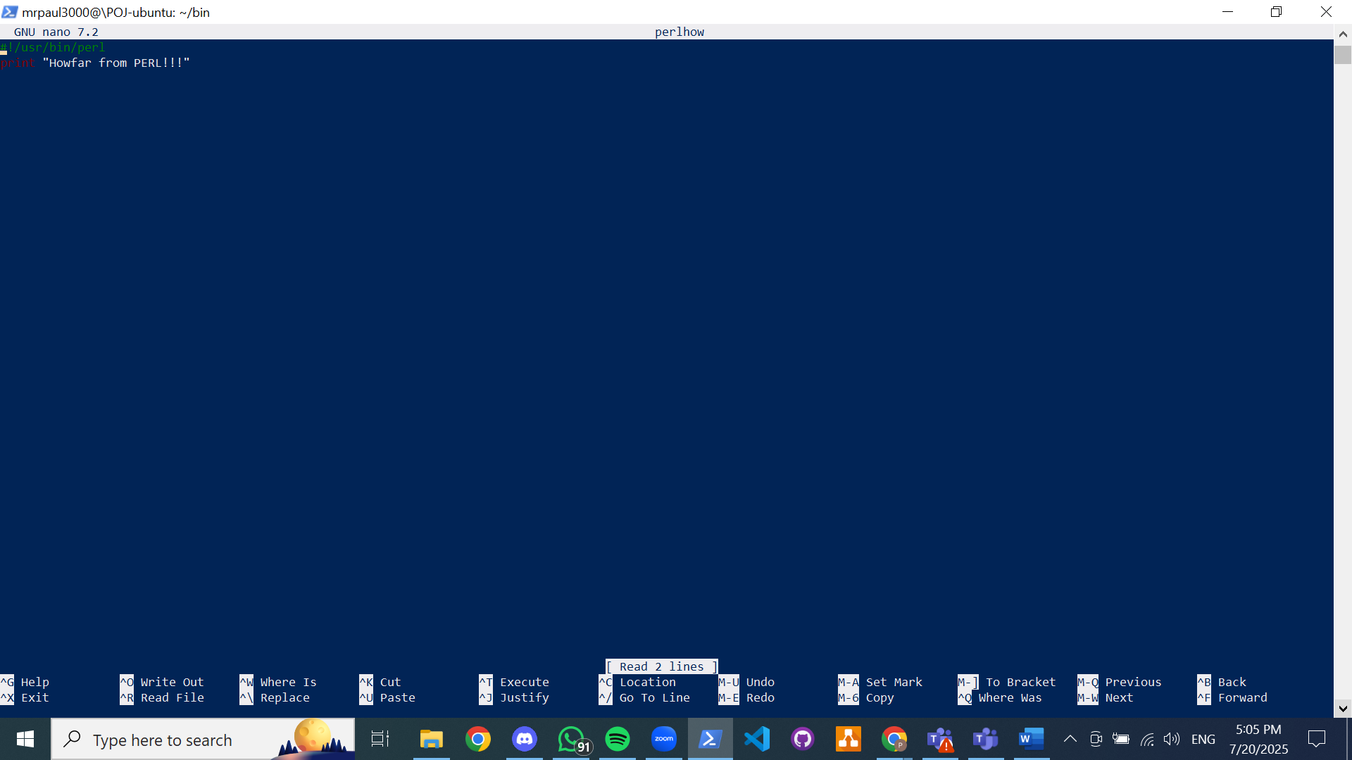

executing python, bash and perl scripts without having to prefix with the script command; use shebang! to direct the shell to which script to use to execute (creating a path for the shell to execute with any language using shebang!)

